**Finite State Automata**

**Wiktor Zmiendak**

1. **Task:**

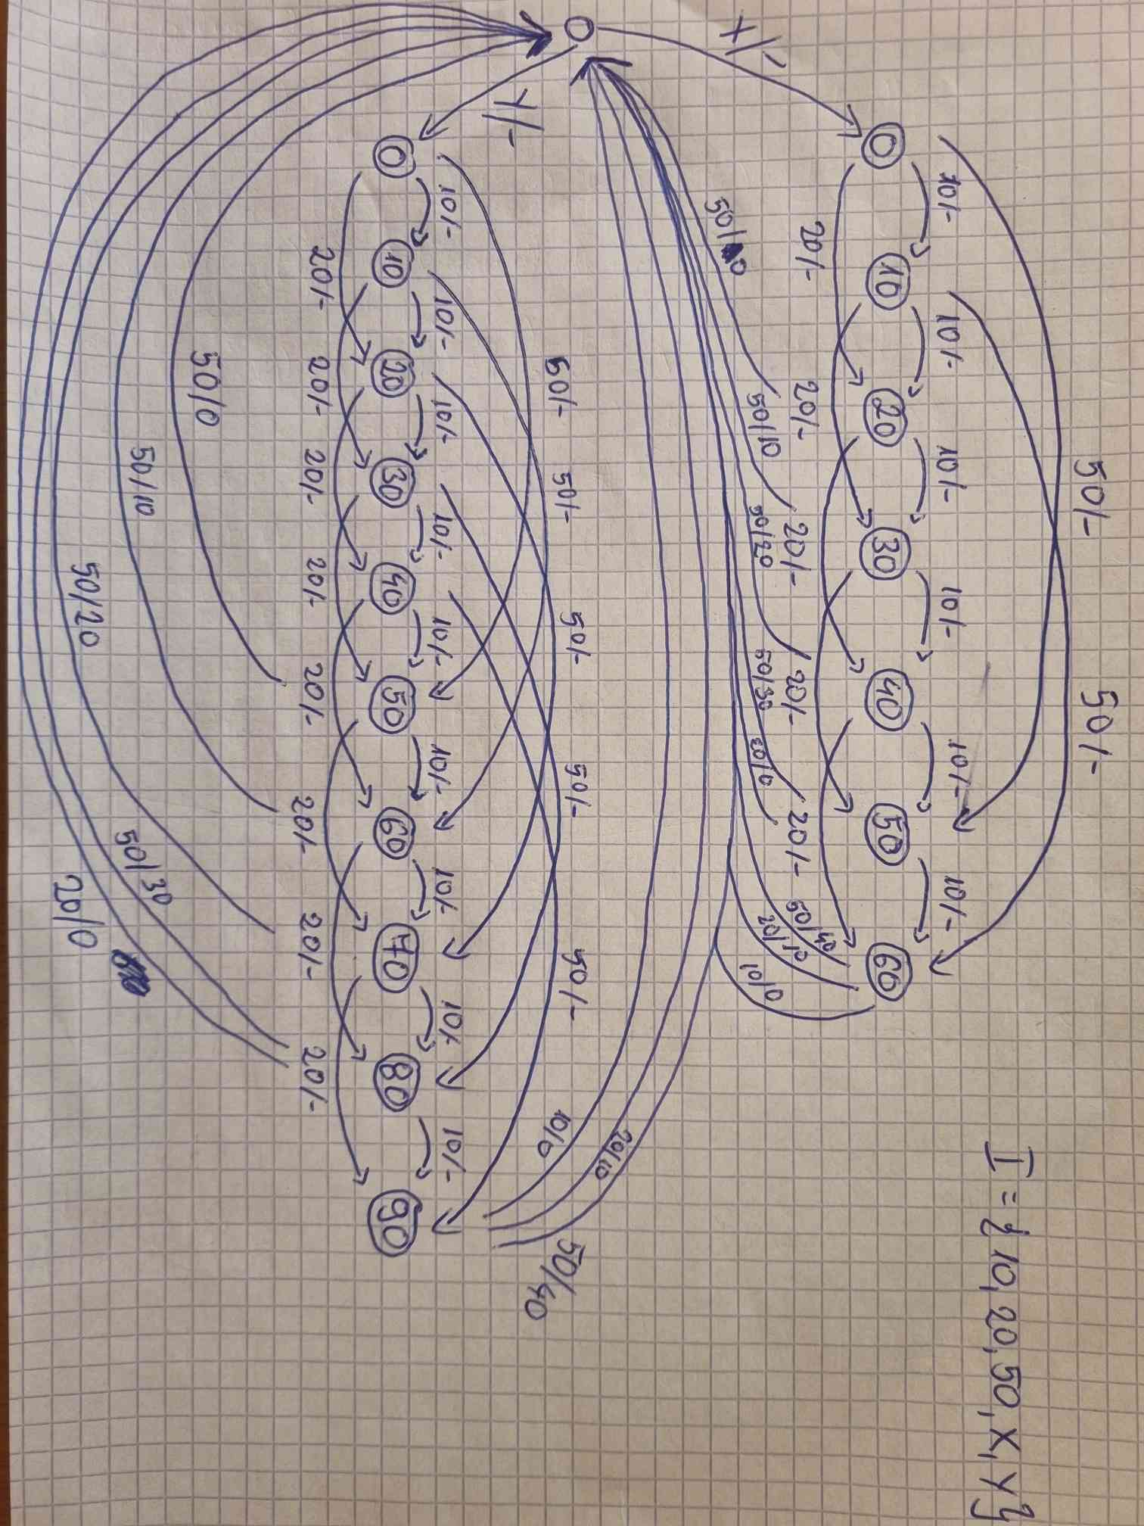Design a Mealy machine that provides token for a two services one for 1€ and second for 70c. It accepts 10c, 20c and 50c coins and gives change.

1. **Solution:**
2. **Description:**

In my solution I designed automaton which has two counting systems. The first input (X or Y) determines which one the machine chooses. Then the machine accepts our coins. If we reach necessary amount we receive product. If the total inserted amount is higher than necessary the automaton gives us change.